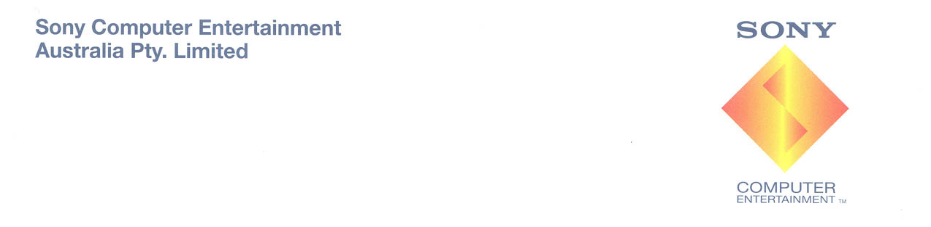
™

PLAYSTATION 3 success paves the way into Christmas

With exclusive new software and ground breaking applications, consumers are in for a great year of “entertainment like you’ve never seen before”

Sony Computer Entertainment Australia (SCE Aust.) today announced that since its Australian launch on 23rd March 2007, over 100,000 PLAYSTATION®3 (PS3™) consoles have now been sold in Australia; reaching the sales milestone in a faster time period than its predecessor, the PlayStation®2.

This success is set to continue, with retailers predicting that the new $699 40GB PS3 will be one of the top selling home entertainment products this Christmas, thanks to its competitive price point, exclusive game range and leading in-built technology. Demand will also be supported by Australian consumers’ continued spending on complementary high definition technologies including Blu-ray movies, Full HD Televisions, camcorders and digital cameras.
Key Features

Blu-ray Disc
Built-in Blu-ray Disc drive delivers a whole new generation in high definition gaming, movies and unmatched digital media storage (up to 50GB on a dual layer disc). The built in Blu-ray Disc player is also spearheading the format’s continued growth and success in Australia. In Sony Australia’s recent High Definition Benchmark, reporting from April to June 2007 and produced by GfK Marketing Services, sales of HD movies increased by 400% from the previous quarter, with Blu-ray continuing to be the format of choice, representing 87.3% of total HD movie sales.

Currently one of the most affordable Blu-ray Disc player on the market, the PS3 is expected to continue to be sought out by consumers looking to experience next generation movies, demonstrating the console’s broad home entertainment appeal beyond purely gaming.

Picture Quality
The PS3 creates a true 1080p high definition image output ensuring superior picture quality.

Future Proof Technology
Thanks to the ability to continually upgrade the operating system of the PS3, the home entertainment console will remain relevant for at least the next ten years and beyond. New applications and internal system software is able to be continually updated to enhance existing functionality or add new features. PS3 System Software version 2.00 has just launched, allowing users to create playlists with their music and photos, turn on and off the PS3 using their PSP and refine parental controls for the internet browser.
Next year, PS3 owners can look forward to PlayTV; a TV Tuner and PVR accessory for the home entertainment unit. The twin channel, High Definition TV tuner and PVR software turns the PS3 into a state of the art TV recorder, allowing users to watch, pause and record up to 40 hours of live TV content with the PS3. PSP™(PlayStation®Portable) owners will also be able to set recordings, watch live TV and recorded TV programs remotely on the PSP via a Wi-Fi connection, or quickly transcode recorded TV shows for high quality viewing to the PSP by USB cable for remote viewing away from the home.
Unique Interconnectivity
The PS3 and PSP are interoperable, enabling easy exchange of photos, videos, games and music between the two. The latest firmware upgrade, for example, also allows users to turn off and on their PS3 at home remotely via their PSP from any Wi-Fi connection in the world.

Content
Connect digital devices like cameras, camcorders and music players directly to the PS3 with a USB cable to share, view and store content via the system’s hard drive.

Connectivity
The PS3 is ‘always-on’ thanks to its built-in Ethernet and Wi-Fi connections, offering a world of online possibilities including multiplayer gaming, text and video messaging, voice chatting, downloading content and browsing the Internet. The PS3 is Bluetooth™ enabled, allowing users to connect a wireless keyboard or mouse to the PS3 for easy Internet surfing.

Software
Christmas is looking like a great time to own a PS3 with a host of new, exclusive titles hitting the market. November sees the release of Ratchet & Clank™: Tools of Destruction™, the duo’s first outing on the PS3. With an exciting storyline and guns galore, Ratchet & Clank: Tools of Destruction carries all the hallmarks of this successful series – but with the kind of visuals usually only seen in Hollywood animations. Uncharted: Drake’s Fortune™ is set for arrival in December and is a pulse-pounding blend of exploration and mystery that sees modern-day fortune hunter Nathan Drake embark on a perilous quest to locate a fabled treasure. In addition to these exclusive first party PS3 titles, there is a great third party software line up in the lead up to Christmas, including Ubisoft’s Assassin’s Creed and PS3 exclusive Haze, RedOctane’s Guitar Hero III: Legends of Rock and Call of Duty 4: Modern Warfare from Activision.

- ends -

For further information on PlayStation products visit the Virtual Press Office at www.scee.presscentre.com/au

Rob Lowe  Hausmann Communications  P: 02 8353 5724  E: rob.lowe@hausmann.com.au | Anna Donnison  Hausmann Communications  P: 02 8353 5749  E: anna.donnison@hausmann.com.au

About Sony Computer Entertainment (end March 2007)
Sony Computer Entertainment Europe (SCEE), based in London, is responsible for the distribution, marketing and sales of PLAYSTATION®3, PlayStation®2 and PSP® (PlayStation®Portable) software and hardware in 102 territories across Europe, the Middle East, Africa and Oceania. SCEE also develops, publishes, markets and distributes entertainment software for these formats, and manages the third party licensing programs for the formats in these territories. Since the launch of PLAYSTATION 3 in Europe on 23 March 2007 and the end of March 2007 over 1.6 million units have been shipped across the SCEE territories, over 5.5 million globally. Between its European debut on 24th November 2000 and the end of March 2007, over 44 million PlayStation 2 consoles have been shipped across the SCEE territories, over 117 million worldwide, making it one of the most successful consumer electronic products in history. Between its European debut on 1st September 2005 and the end of March 2007, over 8 million PSP systems have been shipped across the SCEE territories, with over 25 million shipped worldwide since its Japanese launch in December 2004.
About Sony Computer Entertainment Australia
Sony Computer Entertainment Australia (SCE Aust.) is responsible for the distribution, marketing, sales and network support of PLAYSTATION®3, PlayStation®2 and PSP® (PlayStation®Portable) software and hardware in Australia and New Zealand. SCE commenced trading in 1995. At the end of March 2007, over 2.9 million units of PlayStation®2 consoles and 400,000 PSP® units had been shipped across Australia and New Zealand.
More information about PlayStation products can be found at http://www.playstation.com.au or visit the Virtual Press Office at http://www.scee.presscentre.com/au
PlayStation, PSP and the PlayStation logo are registered trademarks of Sony Computer Entertainment Inc. UMD (Universal Media Disc) is a trademark of Sony Computer Entertainment Inc. All other trademarks are property of their respective owners.

